Ownership Certificate

To Whom It May Concern

This is to certify that the following equipment mentioned below are the sole owned by
Branch of Sudhir Gensets LTD.
Equipment | Tower Light
Brand / Make | Wacker Newson
Asset ID | SLT-0010
Model Number | LTS8K
Serial Number | 18201558
Engine Serial Number | 1KS5969
Rating | 4000 W

Mansoor Ali
Branch Manager
Branch of Sudhir Gensets LTD. Co
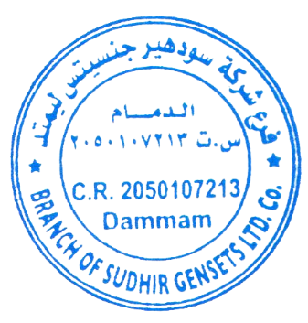
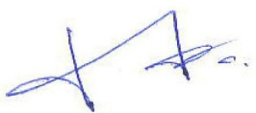
Dammam - KSA

